**EX.NO:3**

**DATE:08-09-2020 CREATING AND PUSHING TO GITHUB REPOSITORY**

**SCREENSHOTS:**

**GIT GUI:**

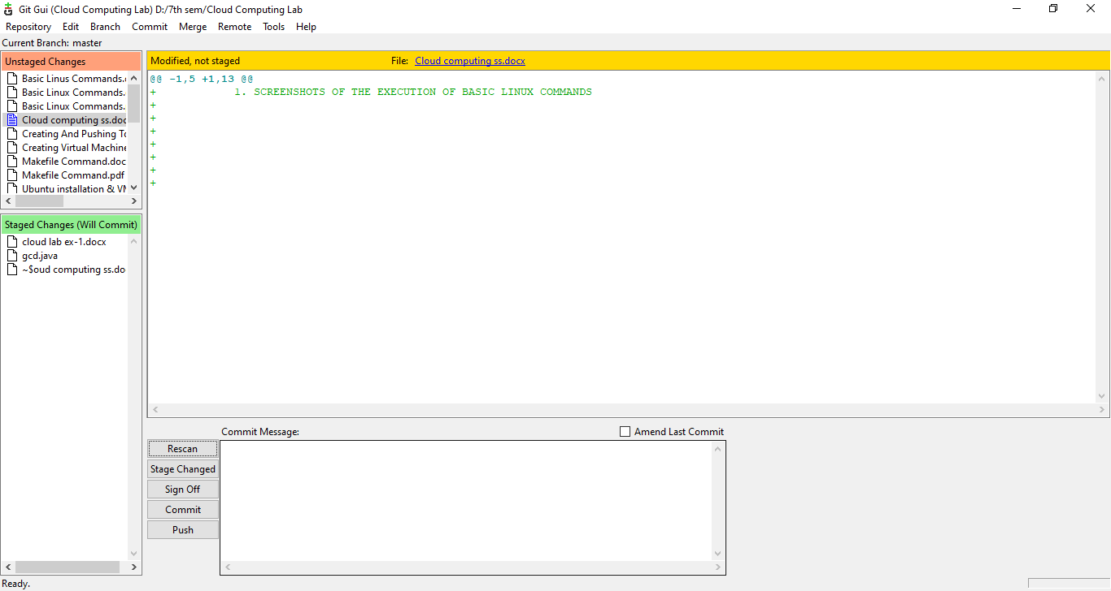

**GITHUB REPOSITORY:**

